
Guidance on adding complementary innovations/enablers/solutions as part of innovations use – IPSR pathway reporting

- When do I need to report complementary innovations/enablers/solutions?
As part of reporting an innovation package via the IPSR innovation use pathway, you are asked to add complementary innovations/enablers/solutions.

There are two types of complementary innovations/enablers/solutions:
- Existing
- New

- What is the difference between existing and new complementary innovations/enablers/solutions?
Existing complementary innovations/enablers/solutions are those that CGIAR and partners are already working on and have been previously reported in the PRMS. This combination of innovations that CGIAR and partners are already working on is also referred to as a ‘bundle’.
When reporting an innovation package in the PRMS, a searchable list of reported and QA-ed PRMS innovations will appear. You can then search and select the complementary innovations/enablers/solutions from this list.

It is strongly recommended to first link to other existing PRMS innovations, before adding additional innovation package innovations/enablers/solutions manually.

New complementary innovations/enablers/solutions are those that have not been previously reported in the PRMS. For these, you will need to provide details on the innovation/enabler/solution.

- Where and how do I report complementary innovations/enablers/solutions?
Within the PRMS, you can report complementary innovations/enablers/solutions under innovation packages -> IPSR Innovation use pathway -> Step 2: Innovation Packaging.

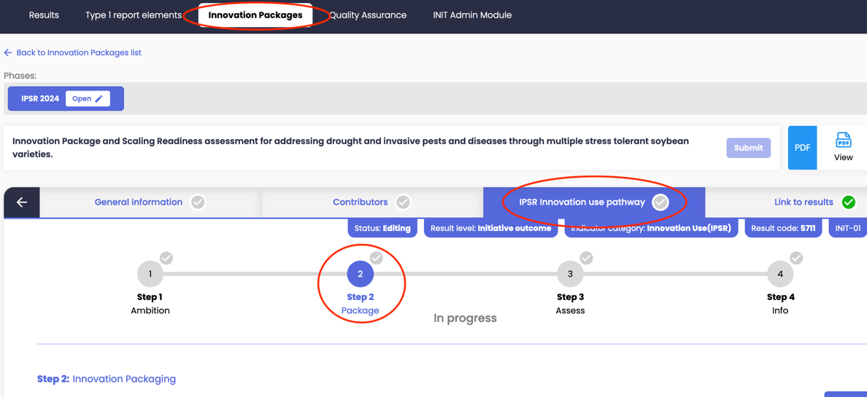

First, existing complementary innovations/enablers/solutions can be selected from the list of existing innovations reported in the PRMS.
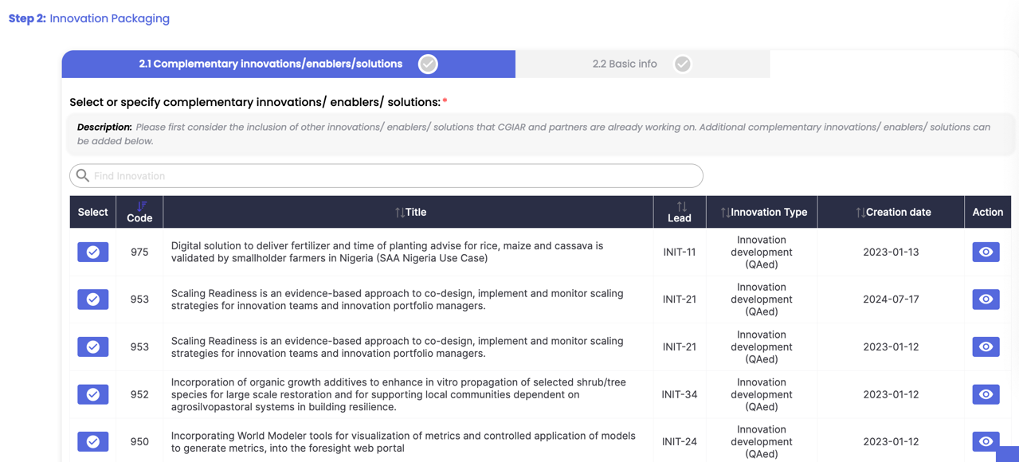

If you have finalized adding existing PRMS complementary innovations enablers/solutions, then you can add additional complementary innovations/enablers/solutions manually by clicking on:

You can then enter the relevant details:

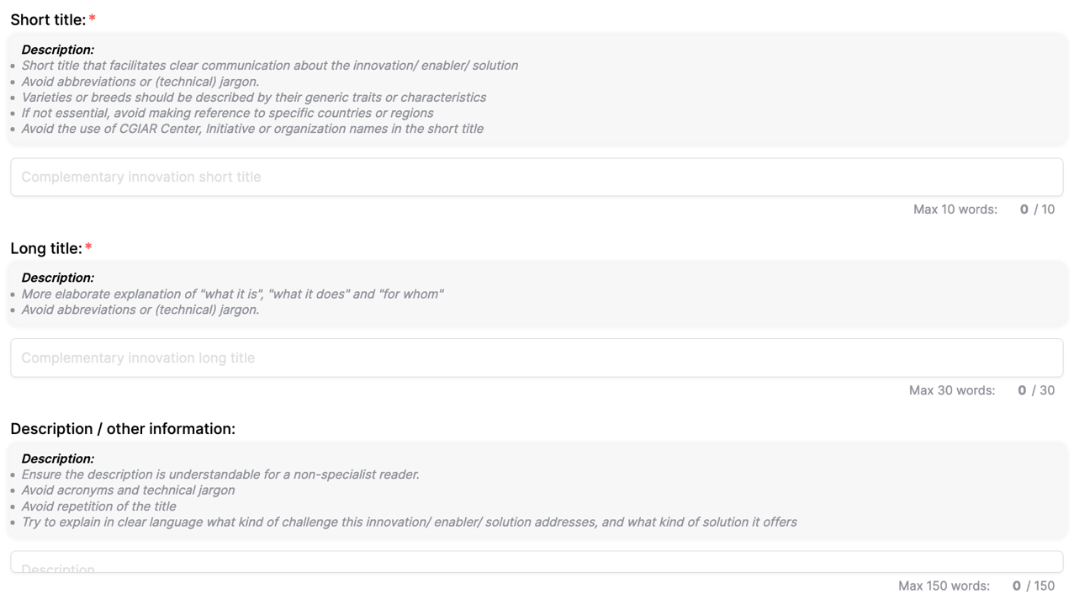

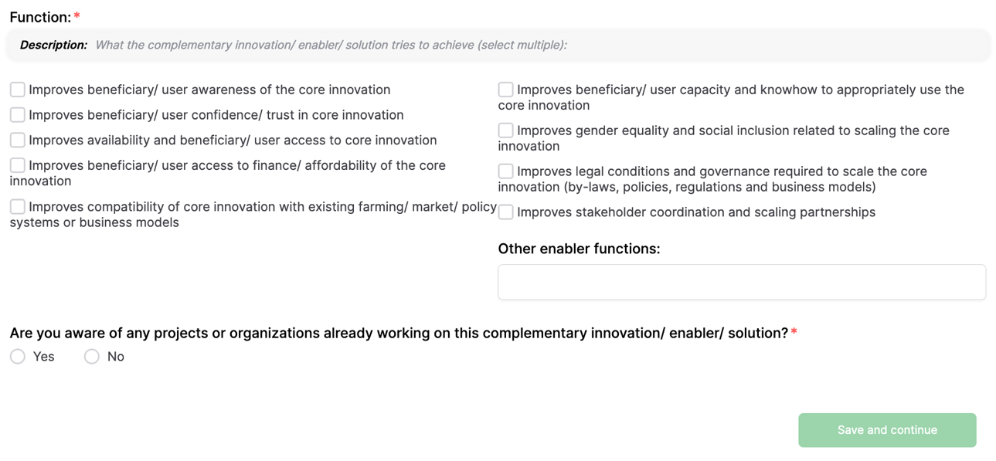
Also see Innovation use - guidance document.

- What are some examples of new complementary innovations/enablers/solutions
Examples of complementary innovations/enablers/solutions are:
- A training program for extension agents on the use of a digital planting date advisory tool.
- A micro-finance solution for youth farmers to increase access to small-scale mechanisation.
- Policy incentives for farmers to reduce pesticide use in potato production.
- A livestock insurance mechanism for farmers to increase their resilience to climate change shocks.
- An information system for female vegetable farmers to negotiate better market prices.
- Improved hygiene guidelines for the poultry sector to reduce animal pest and diseases.
- An awareness campaign to promote the benefits of drought-tolerant maize varieties to farmers.
- A coordination platform for farmer organizations, millers, traders and supermarkets to improve rice sector collaboration and efficiencies.

- Why do I need to add complementary innovations/enablers/solutions?
Innovations scale as part of bundles and packages. These bundles or packages represent the combined technological, market, policy, behavioural and other changes (innovations) that need to take place to achieve a certain outcome or impact.

The IPSR approach supports CGIAR and partners in identifying the complementary elements and assesses which ones are already existing and functional, and which ones need to be developed or improved in a specific context where innovation scaling for impact is aspired.

This provides a starting point for developing scaling strategies with partners that aim to improve the readiness and use of the innovation bundle (interlinked CGIAR innovations) and the package that represents the contextual enabling environment (e.g. market, policy, finance enablers).

